Trajectory optimization

The excitation trajectory for each joint is a finite sum of N harmonic sine and cosine functions. The joint position $q_{i}(t)$, velocity ${\dot{q}}_{i}(t)$, and acceleration ${\ddot{q}}_{i}(t)$ trajectories for joint $i$ of an n-degrees-of-freedom robot are given as
$$q_{i}\left(t\right)=\sum_{l=1}^{N}{\left(\frac{a_{i}^{l}}{ω_{f}l}\sin\left(ω_{f}lt\right)-\frac{b_{i}^{l}}{ω_{f}l}\cos\left(ω_{f}lt\right)\right)+c_{i}}$$
$${\dot{q}}_{i}\left(t\right)=\sum_{l=1}^{N}{\left(a_{i}^{l}\cos\left(ω_{f}lt\right)+b_{i}^{l}\sin\left(ω_{f}lt\right)\right)}$$
$${\ddot{q}}_{i}\left(t\right)=\sum_{l=1}^{N}{\left(-a_{i}^{l}ω_{f}l\sin\left(ω_{f}lt\right)+b_{i}^{l}ω_{f}l\cos\left(ω_{f}lt\right)\right)}$$
With $ω_{f}$ the fundamental pulsation of the Fourier series. This Fourier series specifies a periodic function with period $T_{f}=\frac{2π}{ω_{f}}$. The fundamental pulsation is common for all joints, in order to preserve the periodicity of the overall robot excitation. Each Fourier series contains $2×N+1$ parameters, that constitute the degrees of freedom for the optimization problem: $a_{i}^{l}$ and $b_{i}^{l}$, for $l=1 to N$, which are the amplitudes of the cosine and sine functions, and $c_{i}$ which is the offset on the position trajectory. The offset determines the robot configuration around which excitation will occur. The parameters for all joints are grouped into vector $x$.
For the i-th sampling point,
$$u_{i}=Y_{i}\left(q_{i},{\dot{q}}_{i},{\ddot{q}}_{i}\right)β+ϵ_{i}$$
In matrix form,
$$\left[\begin{matrix}u_{1} \\ u_{2} \\ ⋮ \\ u_{m}\end{matrix}\right]=\left[\begin{matrix}Y_{1}(q_{1},{\dot{q}}_{1},{\ddot{q}}_{1}) \\ Y_{1}(q_{2},{\dot{q}}_{2},{\ddot{q}}_{2}) \\ ⋮ \\ Y_{1}(q_{m},{\dot{q}}_{m},{\ddot{q}}_{m})\end{matrix}\right]β+\left[\begin{matrix}ϵ_{1} \\ ϵ_{2} \\ ⋮ \\ ϵ_{m}\end{matrix}\right]$$
That is,
$$U=Φ\left(a,b,c\right)β+ϵ$$

The problem of determining an excitation trajectory $q^{*}(t)$ can be formulated as
$$\min_{a,b,c}{κ(Φ(a,b,c))}$$
Subject to
$$q_{min}≤q\left(t\right)≤q_{max}$$
$$\left|\dot{q}\right|≤{\dot{q}}_{max}$$
$$\left|\ddot{q}\right|≤{\ddot{q}}_{max}$$
$$q\left(t_{0}\right)=q\left(t_{f}\right)=q_{init}$$
$$\dot{q}\left(t_{0}\right)=\dot{q}\left(t_{f}\right)=0$$
$$\ddot{q}\left(t_{0}\right)=\ddot{q}\left(t_{f}\right)=0$$

The constraints for each joint are
$$\left|q_{i}\left(t\right)\right|=\left|\sum_{l=1}^{N}{\left(\frac{a_{i}^{l}}{ω_{f}l}\sin\left(ω_{f}lt\right)-\frac{b_{i}^{l}}{ω_{f}l}\cos\left(ω_{f}lt\right)\right)+c_{i}}\right|≤\sum_{l=1}^{N}{\frac{1}{ω_{f}l}\sqrt{{a_{i}^{l}}^{2}+{b_{i}^{l}}^{2}}}+\left|c_{i}\right|≤q_{max}$$
Similarly,
$$\left|{\dot{q}}_{i}\left(t\right)\right|=\left|\sum_{l=1}^{N}{\left(a_{i}^{l}\cos\left(ω_{f}lt\right)+b_{i}^{l}\sin\left(ω_{f}lt\right)\right)}\right|≤\sum_{l=1}^{N}{\sqrt{{a_{i}^{l}}^{2}+{b_{i}^{l}}^{2}}}≤v_{max}$$
$$\left|{\ddot{q}}_{i}\left(t\right)\right|=\left|\sum_{l=1}^{N}{\left(-a_{i}^{l}ω_{f}l\sin\left(ω_{f}lt\right)+b_{i}^{l}ω_{f}l\cos\left(ω_{f}lt\right)\right)}\right|≤\sum_{l=1}^{N}{ω_{f}l\sqrt{{a_{i}^{l}}^{2}+{b_{i}^{l}}^{2}}}≤a_{max}$$
Unexpected behavior will result at the start and end points if ${\dot{q}}_{i}\left(t_{0}\right)≠0$,${\ddot{q}}_{i}\left(t_{0}\right)≠0$,${\dot{q}}_{i}\left(t_{f}\right)≠0$ or ${\ddot{q}}_{i}\left(t_{f}\right)≠0$. Therefore, constraints are added to remedy this defect.

$$q_{i}\left(t_{0}\right)=q_{i}\left(0\right)=-\sum_{l=1}^{N}{\frac{b_{i}^{l}}{ω_{f}l}}+c_{i}=0$$
$${\dot{q}}_{i}\left(t_{0}\right)={\dot{q}}_{i}\left(0\right)=\sum_{l=1}^{N}{a_{i}^{l}}=0$$
$${\ddot{q}}_{i}\left(t_{0}\right)={\ddot{q}}_{i}\left(0\right)=\sum_{l=1}^{N}{ω_{f}lb_{i}^{l}}=0$$
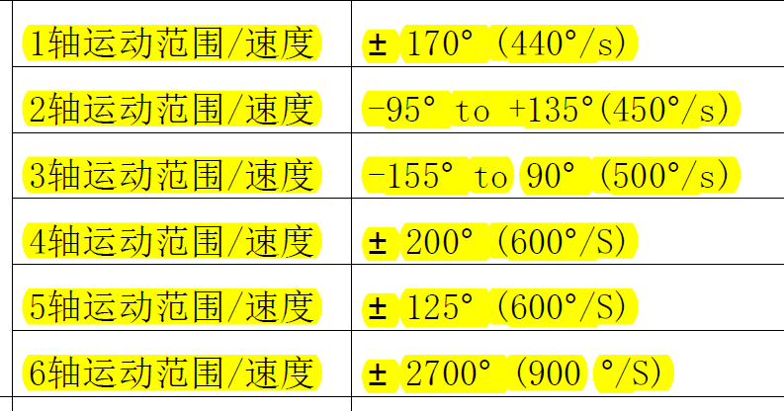

Racer3-0.63减速比如下：
1轴：1:50
2轴：1:80
3轴：1:80
4轴：1:50
5轴：1:50
6轴：1:50

Franka
Limits in the Cartesian space are as follows:

Name Translation Rotation Elbow
p˙max 1.7000 ms 2.5000 rads 2.1750 rads
p¨max 13.0000 ms2 25.0000 rads2 10.0000 rads2
p...max 6500.0000 ms3 12500.0000 rads3 5000.0000 rads3

Joint space limits are:

Name Joint 1 Joint 2 Joint 3 Joint 4 Joint 5 Joint 6 Joint 7 Unit
qmax 2.8973 1.7628 2.8973 -0.0698 2.8973 3.7525 2.8973 rad
qmin -2.8973 -1.7628 -2.8973 -3.0718 -2.8973 -0.0175 -2.8973 rad
q˙max 2.1750 2.1750 2.1750 2.1750 2.6100 2.6100 2.6100 rads
q¨max 15 7.5 10 12.5 15 20 20 rads2
q...max 7500 3750 5000 6250 7500 10000 10000 rads3
τjmax 87 87 87 87 12 12 12 Nm
τj˙max 1000 1000 1000 1000 1000 1000 1000 Nms

0.0504619686813309
-0.0843743621491376
0.100054699873042
-0.116542590051972
0.104882969123647
-0.00250849250969032
0.0441680324096574
0.0268343723158677
0.210774128780459
-0.212022437734765
0.288635561279540
-0.113346079883937
-0.0617250526613452
-0.0735193353863894
-0.0867090884393223
-0.0272512592740232
-0.0318806099118051
-0.0673452918962738
0.0490707035480160
0.0256715314318477
0.0425874415683531
0.107437626668884
-0.0562718886820616
0.0780864280694126
-0.0516471490779072
0.0539064571674477
0.0636771194520985
-0.0723485992965320
-0.0980248792267598
-0.0428766186752368
0.0657619197041153
-0.0531005302533871
-0.0945140499551737
-0.0251151057129107
0.0591124607049109
-0.117901004761665
0.0820386737829796
-0.0408750109404982
0.133255944200198
0.0579412317701598
0.0290210852539886
-0.0563100940179577
0.225384056694958
0.0687101721874361
0.179015851659392
-0.0667803718148779
0.0311995660123151
-0.504704865271416
0.391608182184045
-0.192464483547245
-0.239204293964038
-0.104611105459267
-0.0838413010560911
-0.125780221554282
0.586736041839766
-0.383343057231312
-0.0834069333278452
0.0344229338887735
0.0968358943205884
-0.0777142741760652
-0.0504790156597005
-0.0674349039815375
0.0441745255461798
0.115630815064973
0.0720924256358334
-0.0781333906565675
0.112537159860418
0.0917832727013717
-0.102015972860861
0.0492849598318169
-0.106776055937064
0.0949887849928292
0.0355629203329022
-1.38063773754516
0.0594462411301042
1.39652607052393
0.0519061586686018

